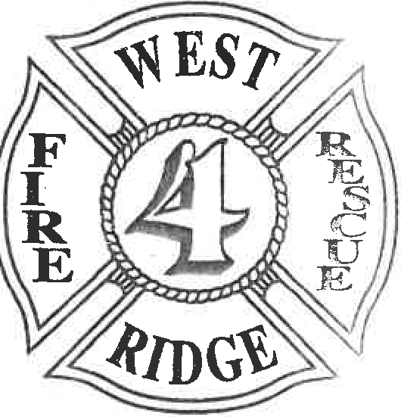
West Ridge Fire Department
3142 WEST 26TH ST• ERIE. PENNSYLVANIA 16506-9890 PHONE 814/833-4440
CHARTERED: JANUARY 25, 1940

ALLIED MEMBERSHIP WRFD
- Allied members are subject to active membership SOG's and SOP's of the West Ridge Fire Department.
- Must obtain a letter from the individuals Chief or President stating the membership of that person is in good standing according to the primary departments' requirements for membership.
- May attend and participate in calls, drills, training, and fundraising events of the Fire Department.
- No voting rights are held by allied members.
- Each year from the time membership starts, allied members must declare the intention to maintain membership status with Fire Department.
- Must obtain a letter yearly from home department Chief verifying that the member remains in good standing for review by the Chief of the Fire Department.
- Allied members will be covered by West Ridge Fire Department Insurance.
- Allied members must be cleared to drive all West Ridge Fire Department vehicles per the WRFD drivers training policy"
- Allied members will be exempt from holding any active officer position.

